- Challenge Name and Category: Mod 26 (Cryptography)
- Difficulty/Points: Easy.
- Description: Cryptography can be easy, do you know what ROT13 is? values.txt
- Flag: picoCTF{next_time_I'll_try_2_rounds_of_rot13_45559abd}
- Solution/Walkthrough: This cryptographic method was identified as Rot13. Any online tool that can decode Rot13 can be used here. Input “cvpbPGS{arkg_gvzr_V'yy_gel_2_ebhaqf_bs_ebg13_45559noq}” and decipher.
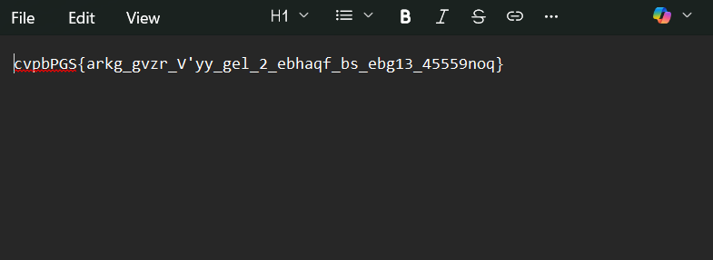
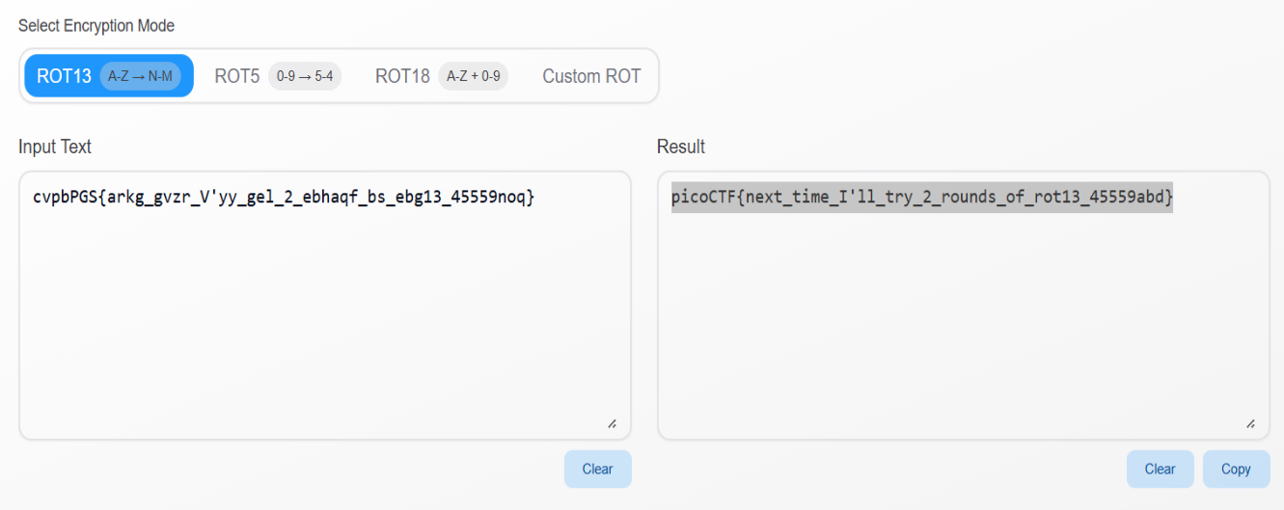
- Tools Used: https://rot13.com/
- Hypothesis Formulation: Decipher the flag from Rot13.
- What Worked vs. What Didn't: Deciphering the flag from Rot13 worked right away.

